Asimov, The Land of Canaan, Houghton Mifflin 1971 First Edition stated First printing 1971. As new unclipped dust jacket price $5.95. As new (never read) hardcover with all 306 pages tightly bound and no marks of any kind. 8vo ISBN 0395125723

ID 000364 Price $110 Box 27
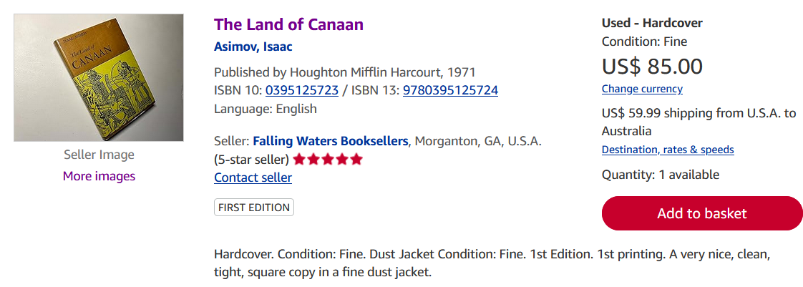
AbeBooks
Ebay $70 to $100
Amazon acceptable $78

